Recursion and other concepts

- A recursive function calls itself

- A recursive function must have a base case where it terminates
- A recursive algorithm must change its state and move towards the base case.
- Recursive functions are especially good to process recursive data structures (such as trees!)

shortcut evaluation
boolean1 && boolean2
boolean1 || boolean2

- In Java, boolean expressions use shortcut evaluation:
  - Evaluation is left-to-right
  - Evaluation stops when the result can be determined.
  - In && expressions, the right side is not evaluated if the left side is false.
  - In || expressions, the right side is not evaluated if the left side is true.
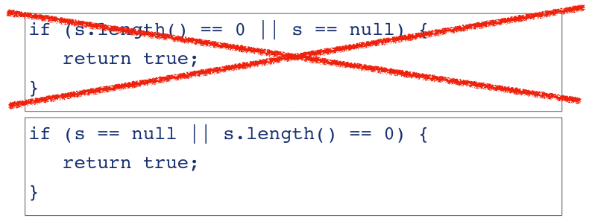
In other words

Returning boolean values
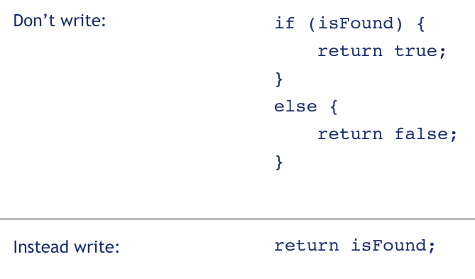

Prefix and postfix increment operators
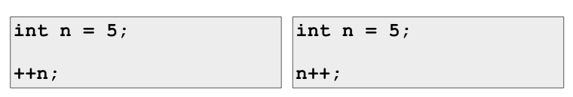
These work as intended

k will be assigned as 5 k will be assigned as 6
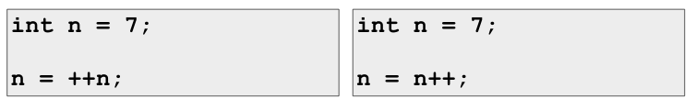
n will be assigned as 8 n will be assigned as 7

Order of evaluation & precedence
- Evaluation order:
  - By precedence:
4 + 6 * 2 = 16
  - Left to right:
4 – 6 + 2

Casting and coercion
- Casting with object types does not change the object.
- Casting with primitive types performs coercion
- Coercion changes the value.
- Java also performs conversion (aka. Implicit coercion) for primitive types wherever possible.
Person person; int a;
Student student; double d;

…
person = student; a = (int) d;
student = (Student) person; d = a;

You may lose precision!


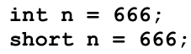

Overriding equals
What does it mean for two objects to be ‘the same’?
- Reference equality.
- Content equality.
In Strings comparisons
- ‘==’ compares references
- equals() compares string content
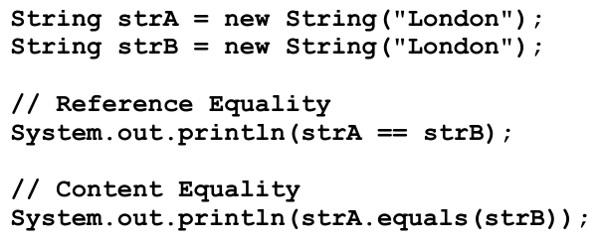

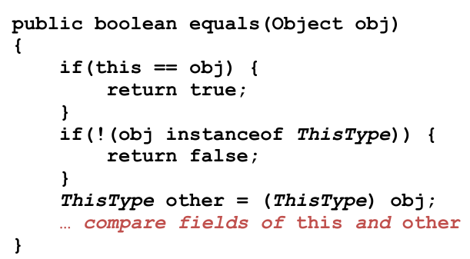

Overriding equals in student
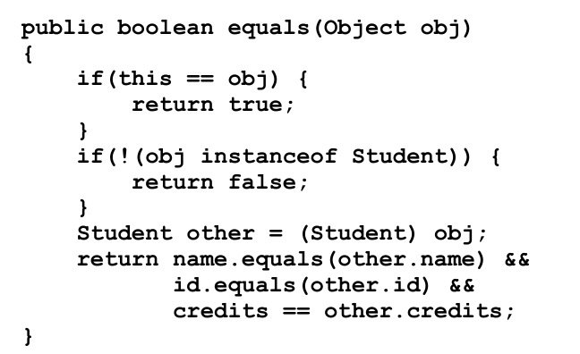

Overriding hashcode in student
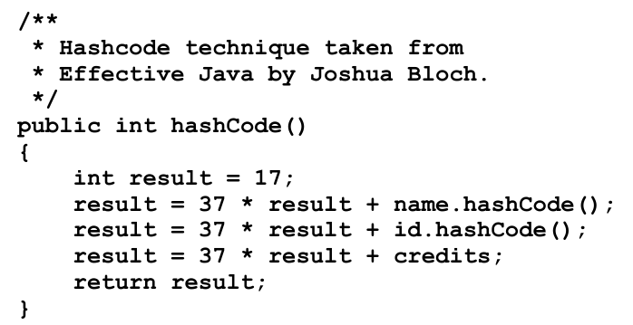

If you override equals, you must override hashCode
- hashCode must generate equal values for equal objects.
- Failure to do so will cause problems with any hash-based collection, e.g. HashMap
- equals and hashCode must use the same set of fields.

